BPNI Certificate Course on Infant and Young Child Feeding Counselling Specialist: A Training Course (The 4 in 1 training course)
(An integrated course on Breastfeeding, Complementary Feeding, Infant Feeding & HIV and Growth Monitoring-Counseling)

registration form

Training Venue and Date:
Place | Date | Name of Course Director
UCMS & G. T. B. Hospital, Dilshad Garden, Near Jhilmil Metro Station,New Delhi, Delhi 110095  011 2258 5007 | 17th- 23rd August 2015 | Prof (Dr.) MMA Faridi HOD Pediatrics

Personal Details
Mr/Ms/Dr______ First Name:________________________ Last Name___________________

Paste your recent passport size photographs
Sex: ___
Educational Qualification_________________________
Profession / Work:______________________________
Describe your present job profile, how it is linked with breastfeeding service
__________________________________________________________________________________________
__________________________________________________________________________________________
Affiliation (association with organizations, institutions and industries) ____________________________________
Correspondence Address:_____________________________________________________________________
__________________________________________________________________________________________
City:_________________________ State:_________________________ Pincode:________________________
Tel: STD Code_______ Off_______________________ Res ___________________ Fax:_________________
E-mail________________________________________________Mobile________________________________
Are you a BPNI Member ◻ Yes ◻ No
How this training is going to help you_____________________________________________________________
- Please send Demand Draft of Rs. 10000/- in Favour of “Breastfeeding Promotion Network of India” payable at Delhi along with your particulars to following address
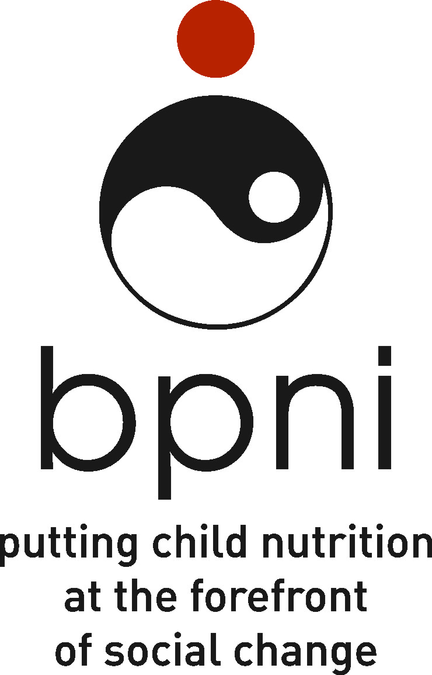
National Coordinator
Breastfeeding Promotion Network of India (BPNI)
BP-33, Pitampura, Delhi-110034. IndiaTel: +91-11-27343608, 42683059 Tel/Fax: +91-11-27343606
Email: bpni@bpni.org

- For any other information contact 27343608, 42683059, 27343606. Email: bpni.india@gmail.com
- *BPNI reserves the right to accept or reject any application
As a policy BPNI does not accept funds or sponsorships of any kind from the companies producing infant milk substitutes, feeding bottles, related equipments, or infant foods or from those who had ever found to violate the IMS Act or International Code of Marketing of Breast Milk

